Mountbolus (MBSB)
Wednesday 18 March 2026
09:49

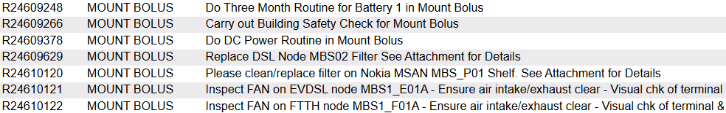

Overall Voltage: 53.57 V
Cell Number | 1 | 2 | 3 | 4 | 5 | 6 | 7 | 8 | 9 | 10 | 11 | 12 | 13 | 14 | 15 | 16 | 17 | 18 | 19 | 20 | 21 | 22 | 23 | 24
Voltage | 2.23 | 2.22 | 2.23 | 2.23 | 2 | 2.23 | 2.23 | 2.23 | 2.23 | 2.23 | 2.23 | 2.23 | 2.23 | 2.23 | 2.23 | 2.23 | 2.23 | 2.22 | 2.22 | 2.23 | 2.23 | 2.23 | 2.23 | 2.24

Do DC Power Routine in Mountbolus

Rectifiers: 5
DC Load: 20.7
Boost Voltage: 56.4
Float Voltage: 53.75

Low Voltage: 47
High Voltage: 58
High Load 80%
High Temperature: 30 C

Low Voltage, High Voltage, High Load, and High Temperature alarms were tested, but only one alarm was detected—a Rectifier fault.

Temperature alarm is not wired.

MPRN: 10015943837

